6. Coding Assignments

1. Hello World Program: Write a Java program that prints "Hello World!!" to the console.

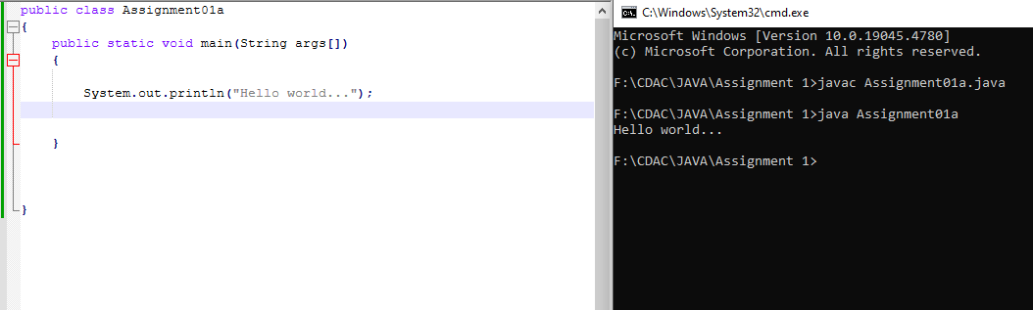

2. Compile with Verbose Option: Compile your Java file using the -verbose option with javac. Check the output. 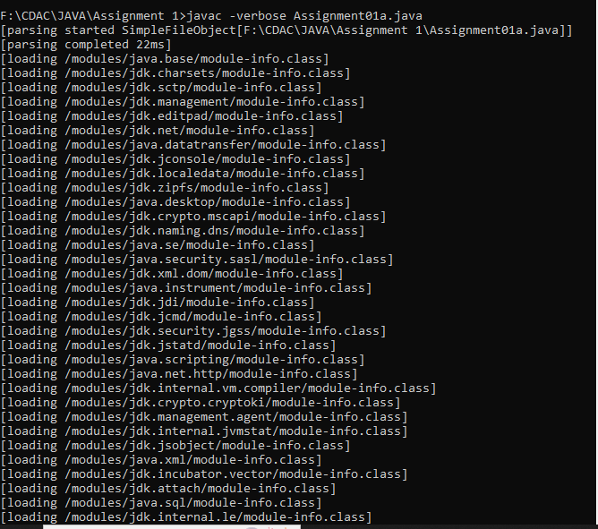

3. Inspect Bytecode: Use the javap tool to examine the bytecode of the compiled .class file. Observe the output.

